Final Project — Final Project PID-Controlled System Using MATLAB and Simulink
Students: Maria Luiza Cabral, Philip Pham, Gerald Springstead and Jordan Nance.
Professor: Pallavi Singh
Class: EEL3013.82833

1) Project Description
This project presents a PID-controlled Ball Balancing System developed using MATLAB, Simulink, and Arduino. The main objective of the system is to maintain the ball at a desired position on a beam by continuously adjusting its angle. The project integrates a real-time feedback loop, where the ultrasonic sensor measures the ball’s position, and the PID controller computes the necessary correction to stabilize it. This type of system is widely used in control engineering education because it demonstrates concepts such as stability, tuning, and closed-loop response in a physical process.
The system design follows the methodology shown in reference demonstrations of ball balancing mechanisms, including the example video used as inspiration for this project.
2) Components Used
2.1 Hardware
- Arduino Uno
- MG996R servo motor (beam rotation)
- HC-SR04 ultrasonic distance sensor
- Wooden or acrylic beam for the ball track
- Steel or plastic ball
- Jumper wires and breadboard
- External 5 V supply when needed for servo stability
2.2 Software
- MATLAB
- Simulink with Arduino Support Package
- Arduino IDE (for initial board testing)
3) Working Principle
The system uses an ultrasonic sensor positioned at the end of the beam to measure the distance to the ball. This distance represents the current position of the ball. The reading is sent to MATLAB/Simulink, where it is processed and compared to a predefined setpoint. The PID Controller block calculates the control signal based on the error, and the output is sent to the servo motor that adjusts the beam angle.
When the beam tilts, gravity causes the ball to roll, creating a dynamic and nonlinear process. The feedback loop repeats continuously, allowing the controller to stabilize the ball near the desired position. The real-time behavior depends on correctly tuning the PID values to reduce overshoot, oscillations, and steady-state error.
4) Circuit Diagram
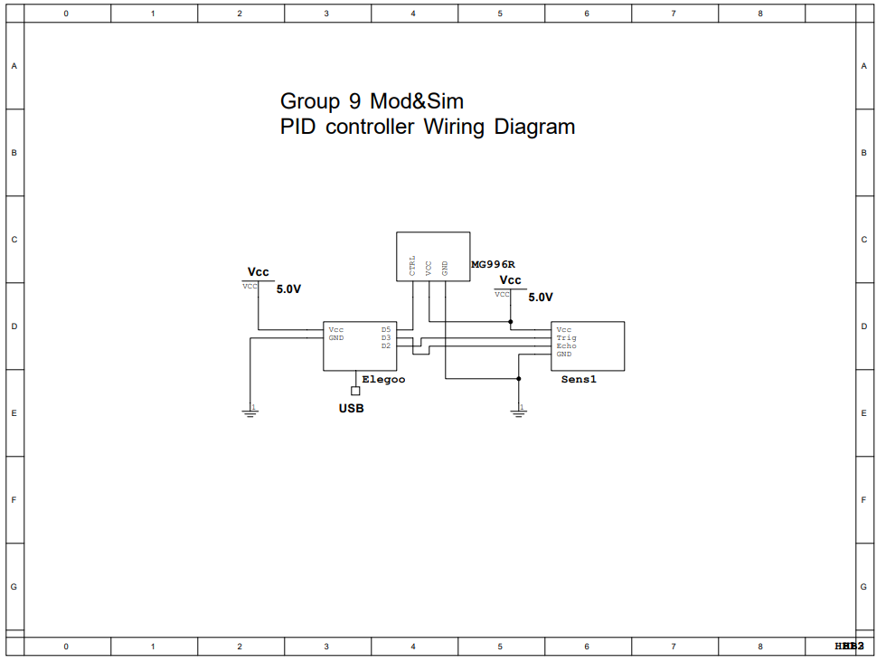
5) MATLAB/Simulink Model + PID Tuning Steps
5.1. System Modeling in Simulink

When Kp = 10, Ki =2, Kd = 0;When Kp = 8, Ki = 2, Kd = 0;

When Kp = 8, Ki = 2, Kd = 0.1;
5.2. MATLAB Code
MATLAB CODE
5.3. PID Tuning Steps
Three different PID configurations were tested to evaluate their impact on the system’s response. When using Kp = 10, Ki = 2, Kd = 0, the system reacted quickly but produced a noticeable overshoot. The high proportional gain caused the ball to move past the setpoint before stabilizing. It took 53 seconds to balance the ball. When Kp = 8, Ki = 2, Kd = 0, the overshoot was reduced, but the system took longer to balance because the lower proportional gain decreased the controller’s responsiveness. The time to balance the ball was 49 seconds. Finally, with Kp = 8, Ki = 2, Kd = 0.1, the system achieved the shortest settling time (43 seconds). The derivative term helped reduce oscillations and improved stability, allowing the ball to reach the setpoint faster and with smoother motion.

6) Project Picture
7) Video Demonstration
Complete Video Project
8) System Response and Performance
The system was able to detect the ball position and adjust the beam angle dynamically using the PID controller. When tuned properly, the ball moved toward the setpoint and remained close to the desired position. Small oscillations occurred due to sensor noise, servo backlash, and the natural instability of the system, but they were minimized with derivative control.
Performance Observations
- Response speed: Fast when Kp is high, but too large values caused oscillations.
- Overshoot: Present during initial trials but reduced after tuning Kd.
- Steady-state error: Nearly eliminated with the addition of Ki.
- Noise influences: The ultrasonic sensor introduced small fluctuations in measurement; smoothing filters can improve this.
Overall, the system demonstrated satisfactory performance for a nonlinear balancing task and responded consistently under typical conditions.
9) Conclusion
This project successfully demonstrated the integration of MATLAB, Simulink, and Arduino to implement a real-time PID control system. The Ball Balancing System provided a practical understanding of closed-loop control, feedback processing, and parameter tuning. Although the system involved challenges such as sensor noise and mechanical variability, the final implementation performed well and met the project objectives. Future improvements could include using a higher-precision sensor, adding digital filtering, or applying advanced control strategies such as LQR.

